**Research Proposal Template**

| This document provides a generic template for a research proposal. Given that it is publicly accessible, the file is read-only. **To customise it, select “File”, followed by ‘’Make a copy’’ or “Download”**. |
| --- |

| **WHERE TO START** |
| --- |

If you are new to proposal writing, our popular online course, **RESEARCH PROPOSAL BOOTCAMP**, is the ideal starting point. To say thank you for downloading this template, we’ve got a special offer for you right here - <https://gradcoach.com/proposal-course/>

[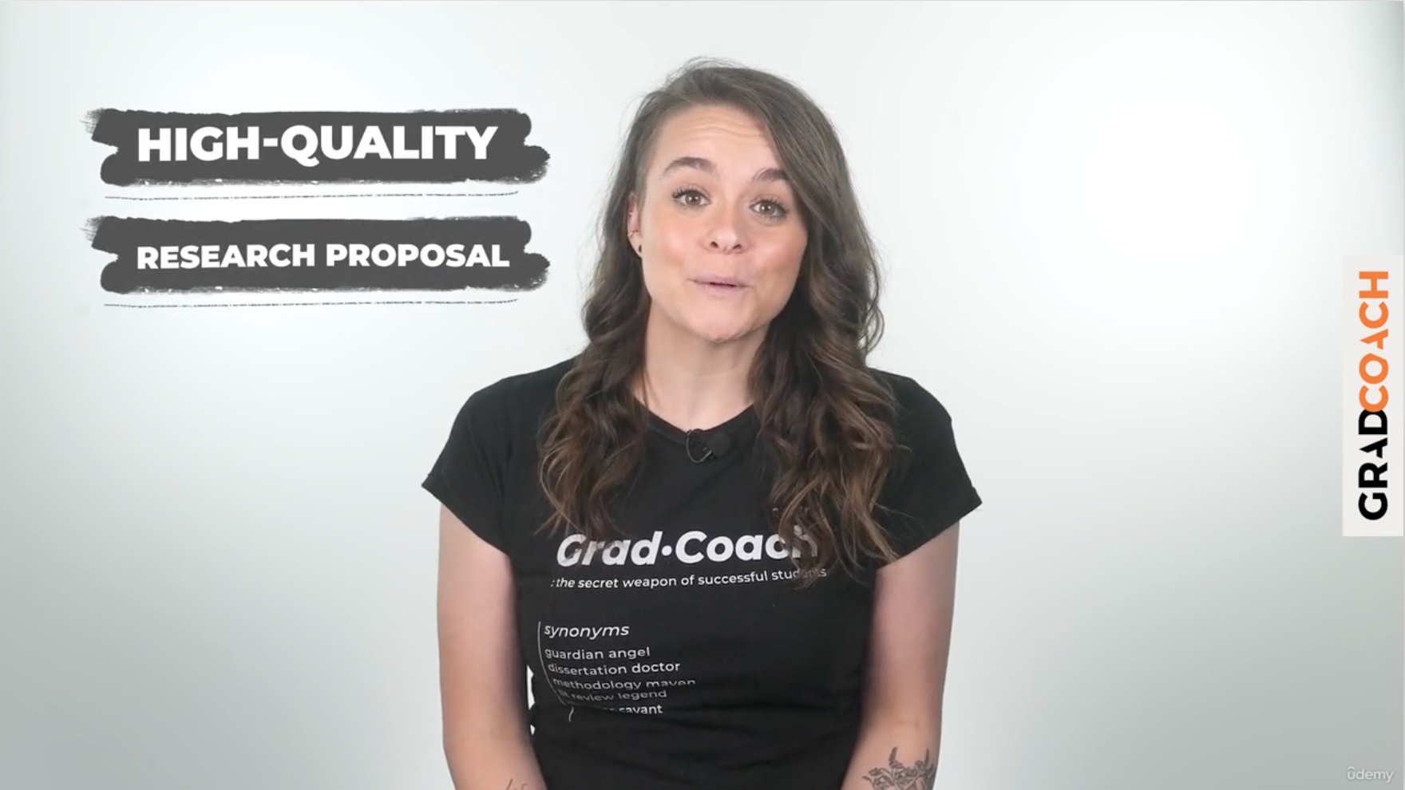](https://gradcoach.com/proposal-course/)

If you are still trying to **figure out your research topic**, you’ll need to iron that out before you start your proposal, or you’ll just end up doing double work. A good starting point is our [topic ideation basics video here](https://gradcoach.com/how-to-find-choose-dissertation-topic/). You can also sign up for our [free webinar covering topic ideation here](https://gradcoach.com/webinar-research-topic/).

Once you’ve got your topic pinned down and are confident that you’re ready to start the proposal writing, you can get started using the template below.

**PLEASE REMEMBER** - always follow any guidelines or templates that your university or institution provides. The template we provide here follows proposal writing best practices, but some institutions have unique requirements or specific priorities. So, make sure that you thoroughly digest and adhere to any instructions they’ve provided.

| **WHERE TO GET MORE HELP** |
| --- |

If you’d like 1-on-1 assistance with your proposal, consider our private coaching service, where we hold your hand through the process, step by step. You can learn more and [book a free consultation here](https://gradcoach.com/dissertation-proposal-help/).

| **Student name:** |  |
| --- | --- |
| **Student number:** | (if applicable) |
| **Email and mobile:** |  |
| **Date:** |  |

# **Introduction**

**Background and context**

| Set the scene by providing some background contextual information for the reader. Explain any core concepts and/or terminology so that someone who is not a topic expert will have the necessary information to understand the research problem that you will present (in the next section. |
| --- |

**Problem statement/research problem**

| Based on the background and context that you’ve just presented, clearly explain and articulate the research problem that you will ultimately aim to address/solve. You may feel that your problem is obvious, but you still need to make it explicit here. Don’t assume that the reader will connect the dots - always write for the non-expert reader.  You can learn more about the research problem here (explainer video and article) - <https://gradcoach.com/research-problem-statement/> |
| --- |

**Research rationale**

| Here you need to clearly explain what value your research will create, both to the research/academic community as well as practitioners. Clearly state who will benefit from your research, how they’ll benefit and, if possible, how much they’ll benefit. Consider all stakeholders. |
| --- |

**Research aims, research objectives and research questions**

| Based on all of the above, clearly state your research aims and objectives. If required, also state your specific research questions.  To learn more about research aims, objectives and questions, see this resource - <https://gradcoach.com/research-aims-objectives-questions/>  For practical examples of research questions, see this resource - <https://gradcoach.com/research-question-examples/> |
| --- |

**Other**

| If there are any other components that your university specifically requires you to discuss in the introduction section, include those here. This may include things such as hypotheses, personal motivations, or something else. Depending on what they are, you may wish to merge them with the preceding sections.  You can learn more about hypotheses here - <https://gradcoach.com/what-is-a-research-hypothesis-or-scientific-hypothesis/> |
| --- |

# 

# **Literature Review**

**Theoretical framework (AKA the foundation of theory)**

| A theoretical framework is a set of concepts and ideas that are used to explain, understand, and guide your study. It provides a way of organising your study within a broader context of existing knowledge and theory.  Start off by discussing and synthesing the key theories, models and frameworks that will form the theoretical foundation of your study. Clearly define and justify all the constructs that you will work with and make sure that any potentially ambiguous terms are defined.  You can learn more about theoretical frameworks here - <https://gradcoach.com/theoretical-framework-vs-conceptual-framework/> |
| --- |

**Empirical research**

| In this section, discuss and synthesise the findings of empirical (evidence-based) studies that are relevant to your proposed study. If your topic is very novel, look at adjacent literature (i.e. research investigating similar or the same constructs within a different context).  In terms of structure, you may wish to present this thematically, chronologically or methodologically. To learn more about these options, see this resource: <https://gradcoach.com/literature-review-structure/> |
| --- |

**Research gap**

| Based on the two previous components, clearly articulate the research gap. It may seem obvious, but you still need to build a clear, strong argument as to what type of gap exists and why that’s meaningful.  To learn more about the research gap, see the following resources:   * <https://gradcoach.com/research-gap/> * <https://gradcoach.com/finding-research-gaps/> |
| --- |

# **Methodology**

**Opening section**

| It’s a good idea to present a brief introduction and overview regarding your methodology upfront. For example, you could state that you will take either a qualitative or quantitative approach (and why). Keep this section brief.  To learn more about qualitative, quantitative and mixed methods, see this resource: <https://gradcoach.com/qualitative-vs-quantitative-research/>  To learn more about writing the methodology section, see this resource: <https://gradcoach.com/how-to-write-the-methodology-chapter/> |
| --- |

**Data collection**

| Clearly describe how you will collect your data - e.g. survey, interviews, focus groups, etc. Justify why you chose this approach and how this will help you achieve your broader research aim(s).  If you plan to undertake interviews, consider watching this video where we discuss common interview mistakes that students make: <https://gradcoach.com/qualitative-interviews/>  If you plan to utilise a survey to collect data, consider watching this video where we discuss common survey design and hosting mistakes: <https://gradcoach.com/survey-design-101/> |
| --- |

**Sampling**

| Clearly describe and justify your sampling strategy. Which sampling method will you adopt and why? What will your sample size be and how will you ensure that you achieve this?  To learn more about sampling strategies, see this resource: <https://gradcoach.com/sampling-methods/> |
| --- |

**Data Analysis**

| Describe in as much detail as possible how you will prepare, clean and analyse the data that you will collect. Try to be as specific as possible regarding your actual analysis method - for example:   * Qualitative - thematic analysis, content analysis, narrative analysis, etc. * Quantitative - descriptive stats, inferential stats, etc.   For each choice, provide a clear, well-argued justification as to why that is the best option, given your resources.  To learn more about qualitative data analysis methods, see this resource:  <https://gradcoach.com/qualitative-data-analysis-methods/>  To learn more about quantitative data analysis methods, see this resource:  <https://gradcoach.com/quantitative-data-analysis-methods/> |
| --- |

**Other**

| If there are any other components that your university specifically requires you to discuss in the methodology section, be sure to include them, either here or as part of the preceding sections. This may include things like:   * Research philosophy (see <https://gradcoach.com/research-philosophy/>) * Research design (e.g., case study, descriptive, correlational, etc.) * Limitations (see <https://gradcoach.com/research-limitations-vs-delimitations/>) * Ethical considerations |
| --- |

# 

# **Practicalities**

**Dissertation/thesis outline or structural overview**

| If required by your university, provide a brief outline of how you will structure your dissertation, thesis or final research project. Try to provide more than just a bullet-point outline though - explain with a line or two, what you’ll cover in each section.  For more information regarding the typical structure, see this resource: <https://gradcoach.com/dissertation-structure/> |
| --- |

**Project plan and timelines**

| If required by your university, provide a provisional project plan for your actual study, outlining the core activities, stages, etc. Consider using a Gantt chart to articulate the timeline you’re working on. |
| --- |

**Budget**

| If required by your university, provide a basic budget for your project. If you are applying for funding, you need to pay particular attention to this section and be as thorough as possible. |
| --- |

**Other considerations**

| Other things that you may consider including within the proposal (not necessarily this section):   * Provisional research title * Anticipated outcomes * Dissemination strategy * Abstract or exec summary - see <https://gradcoach.com/how-to-write-an-executive-summary/> for more info. * Personal statement |
| --- |

# **References & Appendices**

Close off your document by providing a full reference list in the format prescribed by your institution (for example, Harvard referencing, APA, MLA, etc.).

Be sure to use reference manager software to handle this aspect of your document. If you’re not familiar with the options, we recommend using **Mendeley** or **Zotero**. They are both free to use and ensure that your referencing is correct. You can learn about both in our free videos:

* Mendeley - <https://www.youtube.com/watch?v=PJXnfBSq4Lg>
* Zotero - <https://www.youtube.com/watch?v=tnbwKj6-pD8>

If applicable, the final component will be your appendices. This can typically be used to include supporting but non-essential information. However, check what your university expects and don’t expect the appendices to earn you any marks.

# **Bonus Resource**

As a bonus, we’ve prepared a video covering the most common mistakes students make when drafting their research proposals. Be sure to check it out so that you can avoid the common pitfalls: <https://gradcoach.com/research-proposal-rejection-mistakes/>

PS - Remember to check out our popular online course, **RESEARCH PROPOSAL BOOTCAMP**. To say thank you for downloading this template, we’ve got a special offer for you right here - <https://gradcoach.com/proposal-course/>

[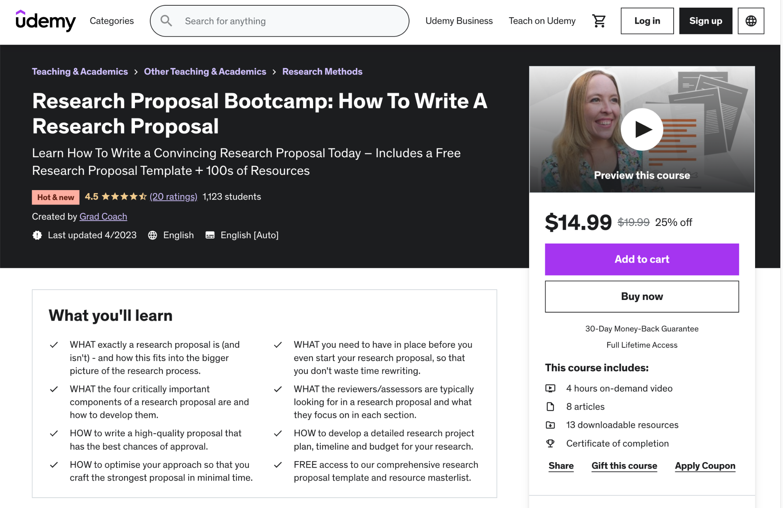](https://gradcoach.com/proposal-course/)